Application Form for the Outdoor Carnival of
2019 the Seventh Wuzhen Theatre Festival

Letter of Commitment

I/Our group have thoroughly read and understood Recruitment Instruction for the Outdoor Carnival of 2019 the Seventh Wuzhen Theatre Festival, and therefore make the commitment as follows:
- The information in Application Form for the Outdoor Carnival of 2019 the Seventh Wuzhen Theatre Festival that I/Our group have filled in and submitted is completely authentic without any misstatement, and I am willing to undertake the corresponding legal liability if there is any falsity according to the investigation.
- I am/Our group are willing to provide my/our performance for the publicity use of Wuzhen Theatre Festival free of charge;
- I/Our group shall be entirely responsible for any intellectual property dispute involving my/our performance.

Representative:
Date:

期：

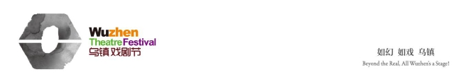

Serial No.:

Application Form for the Outdoor Carnival of
2019 the Seventh Wuzhen Theatre Festival
Performance Information
Performance  Name |  |  | Country/Area
Performance
Description
Performance  Type | a. Play □ b. Music □ c. Dance □ d. Opera □ e. Folk Art □  f. Contemporary Art □ g. Crossover & Creation □  h. Other Type
Performance
Credits
Group
Description
Performance  Time Duration |  |  | No. of Artists (Including directors, actors & staff)
Duration of days in Wuzhen (DOA & DOD) |  |  | No. of Performances
Technical Requirement
Location Requirement
Contact Information | Name |  |  | Email
Contact Information | Telephone |  |  | Cellphone

A. Please email application forms, screenplays (for plays) and performance photos to carnival@wuzhenfestival.com
Mail the hard copy of application forms, screenplays (for plays) and performance videos to Wuzhen Theatre Festival Committee
B. Mailing Address: Yang Duanchen, The Outdoor Carnival Unit, Wuzhen Theatre Festival Committee
No. 18, Shifo South Rd., Wuzhen Town, Tongxiang, Zhejiang, P. R. China (314501)
C. Contact Information: The Outdoor Carnival Unit, Wuzhen Theatre Festival Committee
Tel: 0573-88732588
Email: carnival@wuzhenfestival.com
Website: www.wuzhenfestival.com

